Residents Information

September 2020

Dear Occupant

Island Roads, working in partnership with the Isle of Wight Council is upgrading and maintaining the Island’s highways network. We are writing to let you know about the carriageway surfacing works due to take place in your local area shortly and to provide you with some information and guidance about what will happen during the works to enable you to plan accordingly. **All of the information is important but please take particular note of the sections relating to your weekly waste and recycling collection.**

**Island Roads will continue to follow several new operating procedures in order to comply with the Government’s latest guidance on social distancing as these essential highway improvement works are undertaken. Therefore, we request you respect the safety of all Island Roads workforce by keeping a safe distance from both operatives and resurfacing sites. Should you have any questions, the Island Roads Help Desk is contactable on 01983 822440 or** [**info@islandroads.com**](mailto:info@islandroads.com)**.**

|  |  |  |
| --- | --- | --- |
| **Location of works:** | Victoria Road, Freshwater between Camp Road and Easton Lane | |
| **Anticipated duration of works:** | Start date: Monday 5th October 2020 | Duration: 2 days (we aim to work Monday – Friday only) |
| **Traffic Restrictions** | During the works, we will be using heavy machinery/equipment and materials that could damage your vehicle, making it unsuitable for vehicles to access the works area. **The road will therefore be closed whilst these works are taking place and vehicle access will not be permitted,** with the exception of emergency vehicles. Pedestrian footways will remain open.  **During the works it will be necessary to also close a further section of Victoria Road up to Guyers Road.** Resident access for this section of the road will be maintained with delays. | |
| **Time of works and vehicle access to properties/businesses** | Works will take place between the hours of 06:30 and 18:00, although exact start and finish times may vary. The area of work will be coned the night before the works and this indicates the start of the works the following day. When the cones are in place we ask you to kindly park your cars off street in preparation for the works the next day.  Residents will be permitted access before 07:30 and after 16:00 where safety permits. Please ensure you have a copy of this letter to display. The team on site will have copies for multiple vehicle households. | |
| **Parking /vehicle removal** | Island Roads will remove any vehicles that remain on the carriageway within the road closure and relocate them to a safe alternative location nearby. In these circumstances, you can locate your vehicle by contacting our help desk on 01983 822440. Please note that Island Roads has the authority to remove vehicles in these circumstances from the carriageway and costs may be charged to the registered keeper if a vehicle has to be relocated. | |
| **FAQs** | Visit our website at [**http://www.islandroads.com/7-faqs.html**](http://www.islandroads.com/7-faqs.html) **or alternatively, please contact us for a copy of the FAQs to be sent to you.** | |

**Commercial waste collection**

If our works coincide with your usual arrangements for commercial waste collection please contact your service provider directly to make alternative arrangements with them.

**Household waste and recycling collection**

Your waste collection day will remain the same. However, the collection will take place before daily works begin. Therefore, **please ensure your waste or recycling is at the kerbside before 7am** on your normal collection day**,** the council cannot return for waste set out late. You may set your waste or recycling out from 7pm the night before your collection. Assisted collections will be collected from the agreed set out point. If the crew are unable to access your road due to a change in start or finish time, please leave your waste or recycling out and it will be collected as soon as access is available.

**Access to your property**

Vehicular access will be prohibited during the works. However, we will ensure we meet all of our responsibilities under the Equalities Act so if you require assistance accessing your property or you have any specific requirements please contact us so that arrangements can be made to assist you

(tel. 01983 822 440 or email [info@islandroads.com](mailto:info@islandroads.com)).

**Disabled bays**

If you currently have a disabled bay, please contact our help desk on 01983 822440 as soon as possible. The help desk will take your details and send out a new application form. Alternatively, the forms are printable from our website [**http://www.islandroads.com/49-forms.html**](http://www.islandroads.com/49-forms.html)**. It is essential to reapply** **as without the completed forms disabled bays will not be repainted.**

**Bus services**

Bus stops located within the area of the road closure will not be in operation and alternative stops will be provided outside of the road closure area Bus information is provided on the Southern Vectis website: <http://www.islandbuses.info/> or by calling them on 0330 0539 182.

**Preparatory Works**

In addition to the surfacing there will be preparatory works that need to take place. For these preparatory works, access can be allowed in and out of properties although there may be slight delays.

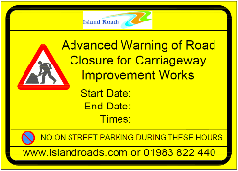**Alterations/Updates**

Please bear in mind that our programme can be affected by various external

influences such as weather. The timeframe provided in this letter is as accurate

as possible at the time of writing. Please take note of the advanced signage

which will be updated in the case of change to dates.

**Location Map**

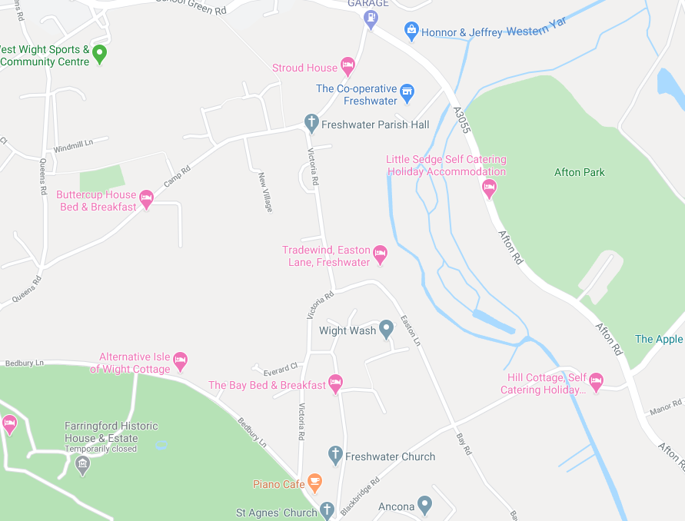

We recognise that these improvement works may cause some inconvenience for local residents and businesses but we hope any disruption will be offset by the long-term improvements we are making. We would like to thank you in advance for your assistance in enabling us to complete these works.

Yours faithfully,

Island Roads